**Revanth Kumar Kanapala 16343832**

**ASSIGNMENT-1**

**Data Analysis of Student Performance Dataset Results**

1.This graph illustrates the distribution of individuals by gender within different racial and ethnic groups in each dataset. The dataset categorizes race/ethnicity into five groups: Group A, Group B, Group C, Group D, and Group E. The graph employs red to represent the count of females and blue to represent the count of males in each of these racial/ethnic categories.

**Conclusion:**

Evidently, the majority of both females and males are affiliated with the Group C racial/ethnic category. The second-highest population of both genders is found within the Group D racial/ethnic category. Conversely, the lowest counts of both females and males are associated with the Group A racial/ethnic category.

2. Histograms have been utilized to visualize the distribution of Reading, Writing, and Math Scores. On the X-axis, you'll find the score ranges for these subjects, while the Y-axis indicates the frequency of occurrence. In summary, it's evident that most students' Reading, Math, and Writing Scores fall within the 60 to 80 range.

In summary, it's evident that most students' Reading, Math, and Writing Scores fall within the 60 to 80 range.

3.The graph provides a comparative analysis of different score categories between males and females. On the X-axis, you'll find the score types being examined for each gender, while the Y-axis represents the corresponding counts.

Based on the data presented in the figure, it's evident that males tend to excel in math, while females tend to achieve higher scores in both reading and writing.

In summary, the figure illustrates a trend where males generally outshine females in math, while females exhibit stronger performance in reading and writing.

4.The graph presents a comparison of score categories in relation to whether students, both male and female, completed a test preparation course. The X-axis distinguishes between those who completed the course and those who did not, while the Y-axis displays the different score types.

In summary, it can be observed that the influence of test preparation courses on student performance varies slightly based on both the type of score and the gender of the students.

5.To conclude, it's evident that the impact of test preparation courses on student performance exhibits some variability, influenced by both the type of score and the gender of the students.

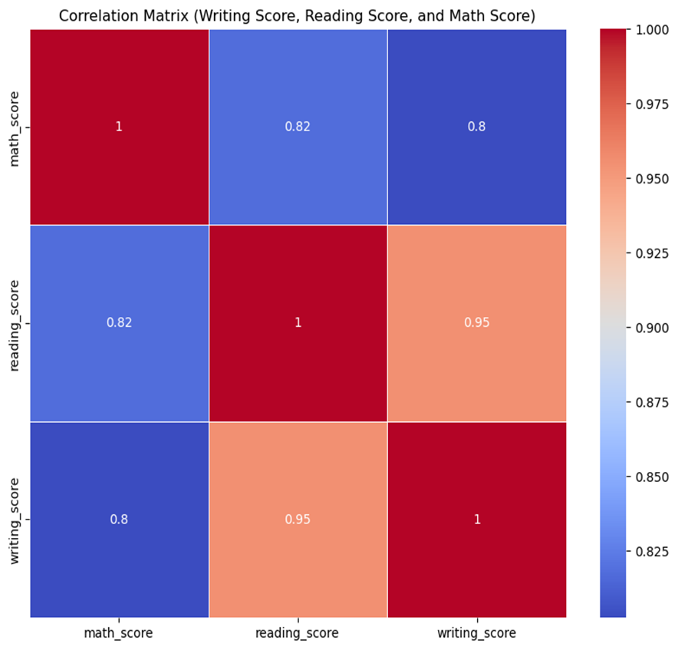

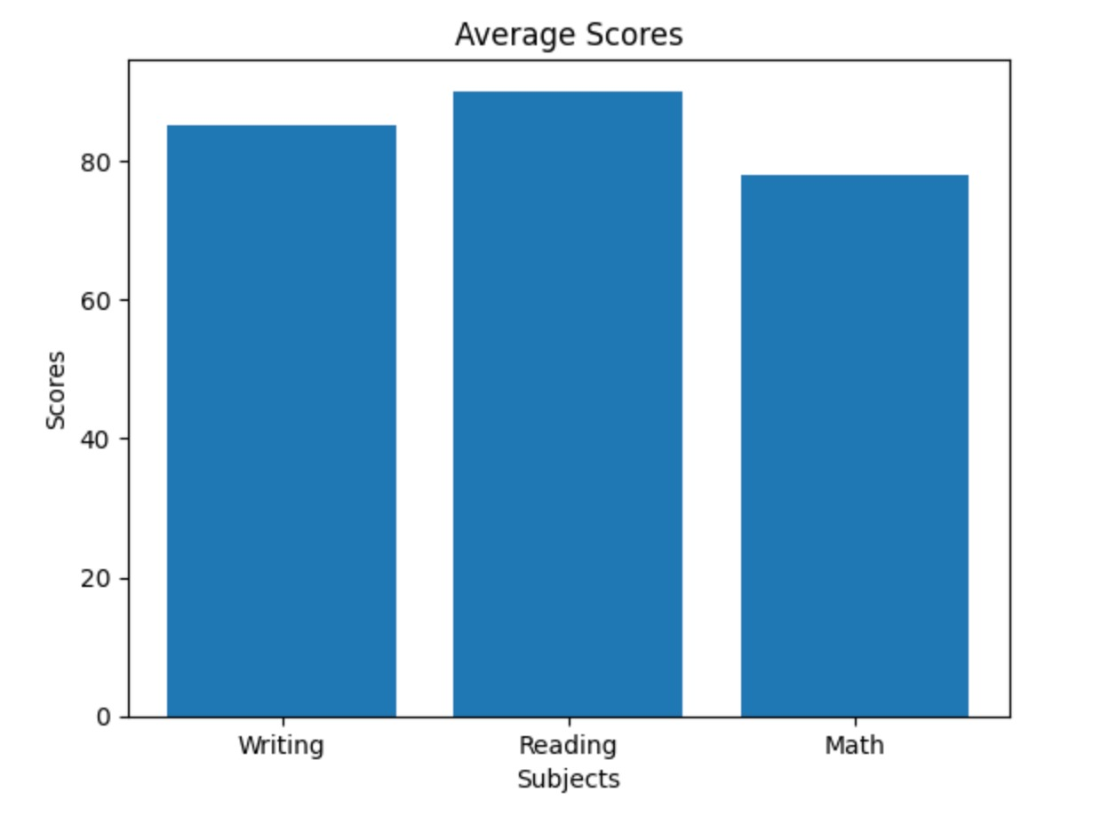

Conclusion:

In summary, there is a positive correlation between Reading and Writing Scores, while both Reading and Writing Scores exhibit a negative correlation with Math Scores.